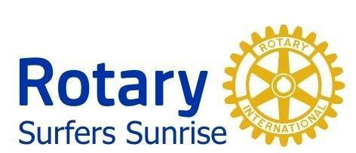
Presidents since Charter since February 1987
Year | President | Comments
1986/1987 | Bill Moir | Charter President
1987/1988 | Roger Berther
1988/1989 | Ralph Pownall
1989/1990 | Keith Leaver
1990/1991 | Paul Blakey
1991/1992 | Bryan Whyte
1992/1993 | John Cillekens
1993/1994 | Peter Morgan
1994/1995 | Ian Mayberry
1995/1996 | Geoff Croad
1996/1997 | Graeme Isaacson
1997/1998 | Franz Huber
1998/1999 | Phil Parry
1999/2000 | Neil Beattie
2000/2001 | Angus Miller
2001/2002 | Barry Lea
2002/2003 | John Appleton
2003/2004 | Keith Lutz
2004/2005 | Des La Rance
2005/2006 | Doug Lipp
2006/2007 | Ian Mayberry | Taking over as Vice President
2007/2008 | Peter Baruch
2008/2009 | Neil Thurlow
2009/2010 | Darrell Brown
2010/2011 | Ray Higgs
2011/2012 | George Keily
2012/2013 | Gerald East
2013/2014 | Darrell Brown
2014/2015 | Conrad Martens
2015/2016 | Paul Seymour
2016/2017 | Simon Brook
2017/2018 | Andy Bell
2018/2019 | Jo Winwood
2019/2020 | Mario Fairlie
2020/2021 | Charles Thomasson
2021/2022 | Paul Seymour
2022/2023 | Mitch Brown
2023/2024 | Doug Lipp
2024/2025 | Andy Bell
2025/2026 | Paul Seymour
2026/2027 | Mario Fairlie

